PROMPT ENGINEERING LAB: (SOLO + PAIR)
Name: Nikita Chobotar Partner: Maksym Perepelytsia
Section: CEP146 Date: 2026-11-11 AI tool used: ChatGPT

===== SECTION 1: SOLO =====
PART 1: SPOT THE PROBLEM
# | Main mistake | My better prompt
1 | Too vague | My laptop is running slowly and sometimes freezes. What can I do to fix it?
2 | Ignoring AI limitations | Which 3 NHL teams have the best chance of winning the Stanley Cup next season? Explain why.
3 | Assuming the AI knows your context | I'm trying to open a PDF file on my laptop, but nothing happens. How can I fix it?
4 | Output format not specified | Give me a short shopping list for 5 healthy breakfasts using cheap ingredients.
5 | Overloading with information | Help me plan a 7-day trip to Japan. First, make a simple plan of places to visit each day.

PART 2: PROMPT MAKEOVER
Scenario chosen (S1–S5): S1
Version 1 prompt: Write an email to my professor asking for more time to finish my assignment.
Screenshot: 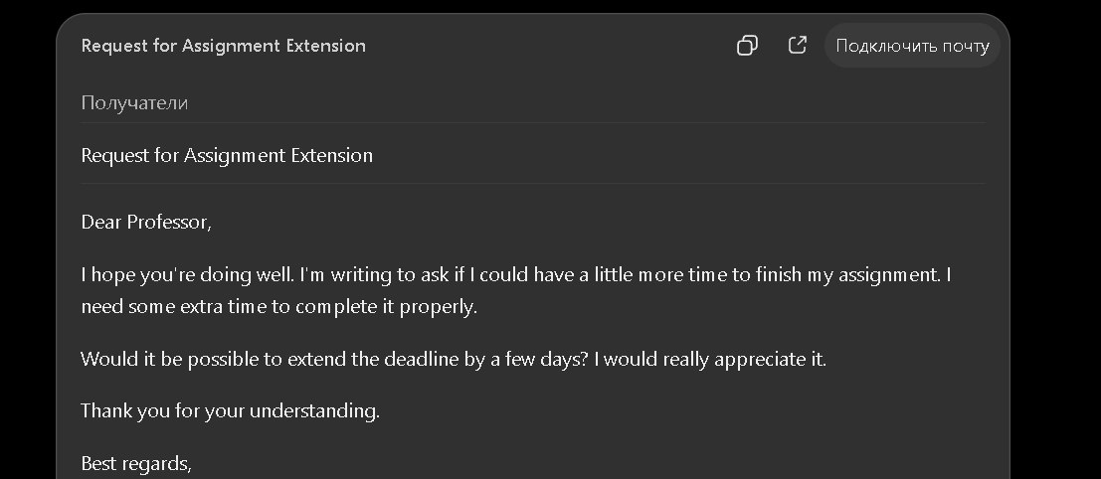
Version 2 prompt (labelled):
[Context]: I'm a college student, and I need two more days to finish my assignment.
[Task]: Act as a student and write an email to my professor asking for a 2-day extension.
[Format]: Include a subject, greeting, short message, and closing.
[Example]: Use something like "Could I please have two extra days to finish my assignment?"
[Constraints]: Keep it under 100 words. Use simple and polite English. Don't make up excuses.
Technique used: Role-playing
Screenshot: Version 2 answer
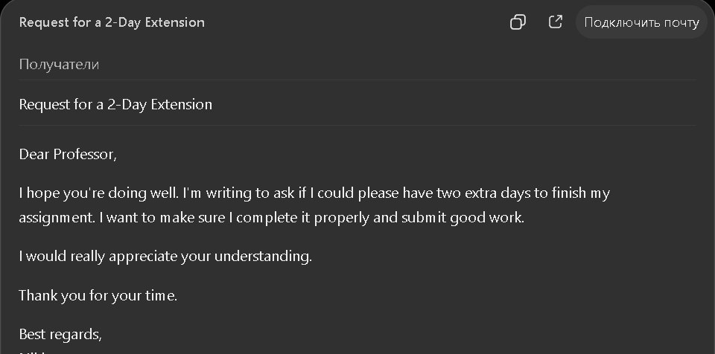

===== SECTION 2: PAIR =====
PART 3: PEER REVIEW I RECEIVED
Reviewed by: Maksym Perepelytsia
Context ✓ Task ✓ Format ✓ Example ✓ Constraints ✓ Technique ✓
Suggestion from my partner:
Your prompt is clear and well-structured. I suggest adding the assignment name and original deadline to the context. This would help the AI write a more specific and realistic email to your professor.
PART 4: PROMPT CHAIN
Task chosen (C1–C3): C3
Prompt 1: "Give me 5 important things I should do before moving into my first apartment."
Prompt 2: "From the list you gave me, explain the second step in more detail. Make a simple checklist."
Prompt 3: "Turn that checklist into a table with 3 columns: Task, Deadline, and Done."
Screenshot of final answer:
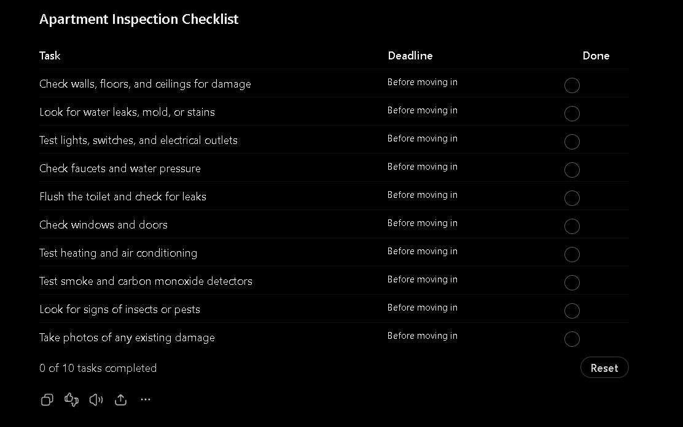

PART 5: REFLECTION (my own words)
Q1: My partner's feedback helped me understand that I should add more details to my prompt. I learned that giving AI more context can make the answer better.
Q2: I wouldn't fully trust AI to predict who will win the Stanley Cup. AI has limitations and can't know exactly what will happen in the future.

